**Hanzla saeed**

**472684**

**Section C**

**Lab manual 8(Home Tasks)**

**Q#1**

*Q#1 code only*

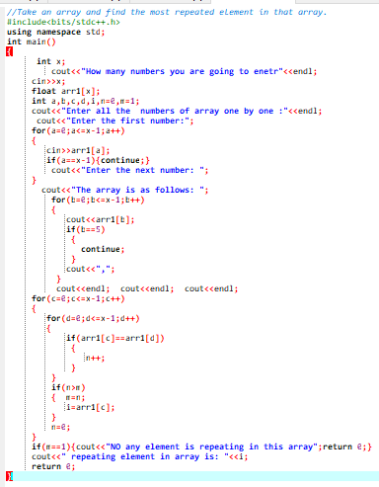

*Q#1 output only*

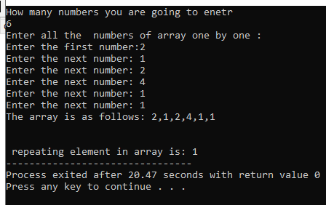

**Q#2**

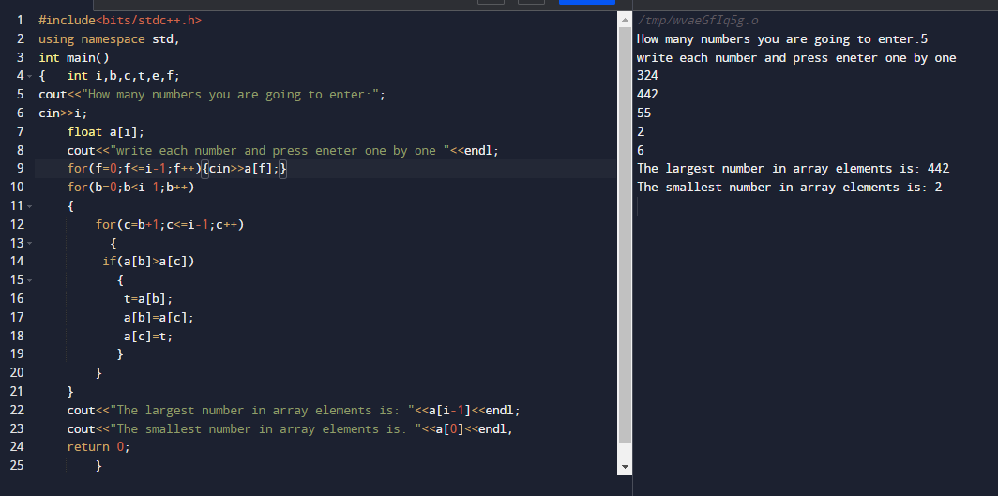

**Q#3**

